Exploring missing proteins expression in gastric cancers and their potential as biomarkers

Chunhui Gu1, 2, Irajizad Ehsan1, 2, Yining Cai2, Fu-Chung Hsiao2, Samir Hanash2*

1. The University of Texas MD Anderson Cancer Center, Department of Biostatistics

2. The University of Texas MD Anderson Cancer Center, Department of Clinical Cancer Prevention

# Abstract

**Background**

“Missing proteins (MPs)” are proteins lacking sufficient supporting evidence from mass spectrometry or other direct protein methods [1]. The lack of reliable proteomics techniques and high expression variation between different cells or tissues may be the reason why those MPs are considered missing. The number of MPs has been constantly reduced due to the development of detection techniques and through efforts from the growing community [2]. Gastric cancer accounts for 1.5% of all newly-diagnosed cancers in the US [3] and can only be diagnosed by gastroscope. Proteomics, especially MPs could be the answer to its lack of effective low-cost non-invasive screening tests. Therefore, it is crucial to have a better understanding of the expression fingerprint of MPs and the difference between regular proteins in gastric cancer patients.

**Objective**

To explore the distribution characteristics of expressed missing proteins in gastric cancer primary cell samples and how it is different from regular proteins. In addition, we try to find robust missing protein(s) as biomarker(s) for gastric cancer.

**Methods**

The accessions of a total of 1343 MPs (PE2, 3, 4 proteins) were extracted from the Nextprot database on date 11/15/2022. [How MS counts were generated and how FDR is controlled]. Normalized spectral abundance factors (NSAFs) [4] were calculated using mass spectrometry (MS) spectral counts (SCs) from 8 different gastric-cancer primary cell samples. Transcripts per million (TPM) [5] were calculated using RNA-seq count data from the same 8 samples and were matched with their MS proteomics data to check the association between proteomics expression and DNA expression for both MPs and regular proteins on the gene level [6].

**Results**

Six of the eight samples showed a similar level of missing protein detection (Table 1). The proportion of protein products with corresponding RNA products was 54.70% and 58.04% respectively for missing proteins with and without the two potential outliers, which in comparison were 90.38% and 91.02% for regular proteins. Missing proteins were completely undetectable in low abundance (Figure 1, top left). There is a strong linear association between protein expression and RNA expression for missing proteins with RNA products (R=0.15, p = 0.025) but not as strong as regular proteins (R=0.38, p<2.2e-16). Missing proteins gene CTAGE1 were detected and had RNA products in all 6 non-outlier samples.

**Discussion**

The highly-truncated expression distribution pattern of missing proteins could be partially explained by the insensitivity of count-based-MS proteomics in low-abundance proteins [7]. However, this cannot explain alone by seeing only a mild truncated pattern in regular proteins. The either-feast-or-famine expression pattern in missing proteins in this study suggested that the detected missing protein is very likely to be disease-specific proteins. The detection of missing proteins product Q9HC47 (CTAGE1) and support from RNA-Seq data gave strong evidence for its existence in gastric cancer and may be a potential biomarker in gastric cancer screening.

Table 1. The proportions of proteins products with RNA products for missing proteins and regular proteins

|  |  |  |  |  |  |  |  |  |  |  |  |
| --- | --- | --- | --- | --- | --- | --- | --- | --- | --- | --- | --- |
|  |  | **IP0981\*** | **IP0982** | **IP0993** | **IP0995** | **IP0999** | **IP7100** | **IP7103\*** | **IP7105** | **Total**  **with outlier** | **Total without outlier** |
| **Missing Proteins** | **RNA product (+)** | 8   (50.00%) | 39  (59.09%) | 24  (55.81%) | 20  (55.56%) | 22  (57.89%) | 18  (64.29%) | 7  (25.93%) | 25  (56.82%) | 163  (54.70%) | 148  (58.04%) |
| **RNA product (-)** | 8 | 27 | 19 | 16 | 16 | 10 | 20 | 19 | 135 | 107 |
| **Total protein products** | 16 | 66 | 43 | 36 | 34 | 28 | 27 | 41 | 298 | 255 |
| **Regular Proteins** | **RNA product (+)** | 3155 (90.43%) | 6028  (88.99%) | 6119  (91.02%) | 4730  (90.94%) | 5162  (92.20%) | 4157  (91.6%) | 3693  (85.17%) | 5465  (91.88%) | 38,509  (90.38%) | 31,661 (91.02%) |
| **RNA product (-)** | 334 | 746 | 604 | 471 | 437 | 381 | 643 | 483 | 4099 | 3122 |
| **Total protein products** | 3,489 | 6,774 | 6,723 | 5,201 | 5,600 | 4,538 | 4,336 | 5,948 | 42,608 | 34,783 |

**\* Sample IP0981 and IP7103 were potential outliers.**

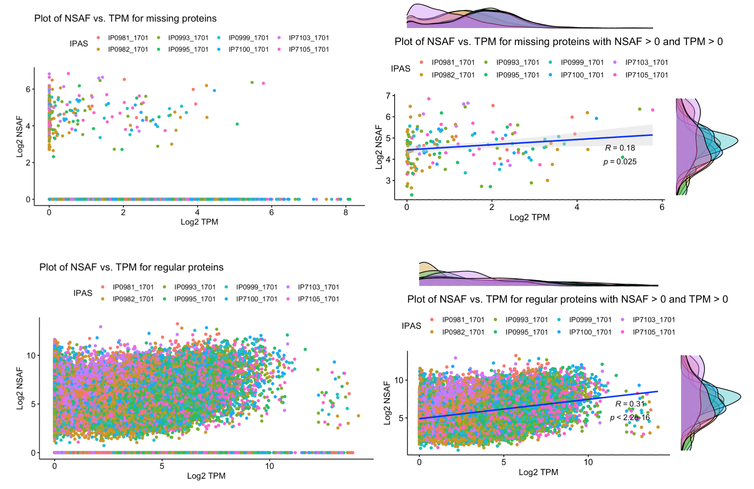

Figure 1. The scatter plot of protein-RNA-product matched pairs. Top left: All protein-RNA pairs for missing proteins. Top right: protein-RNA pairs with TPM > 0 and NSAF > 0. Bottom left: All protein-RNA pairs for regular proteins. Bottom right: All protein-RNA pairs for regular proteins with TPM > 0 and NSAF > 0.

1. Baker, M.S., et al., *Accelerating the search for the missing proteins in the human proteome.* Nature Communications, 2017. **8**(1): p. 14271.

2. Omenn, G.S., et al., *Progress on Identifying and Characterizing the Human Proteome: 2019 Metrics from the HUPO Human Proteome Project.* J Proteome Res, 2019. **18**(12): p. 4098-4107.

3. American-cancer-society. *Key statistics about stomach cacner*. 2022 [cited 2022 11/15]; Available from: <https://www.cancer.org/cancer/stomach-cancer/about/key-statistics.html#:~:text=The%20American%20Cancer%20Society's%20estimates,6%2C690%20men%20and%204%2C400%20women>).

4. Paoletti, A.C., et al., *Quantitative proteomic analysis of distinct mammalian Mediator complexes using normalized spectral abundance factors.* Proceedings of the National Academy of Sciences, 2006. **103**(50): p. 18928-18933.

5. Conesa, A., et al., *A survey of best practices for RNA-seq data analysis.* Genome Biology, 2016. **17**(1).

6. Edfors, F., et al., *Gene-specific correlation of RNA and protein levels in human cells and tissues.* Mol Syst Biol, 2016. **12**(10): p. 883.

7. Lundgren, D.H., et al., *Role of spectral counting in quantitative proteomics.* Expert Rev Proteomics, 2010. **7**(1): p. 39-53.